Simple Harmonic Motion Problems

- The graph below shows an object’s displacement as a function of time.
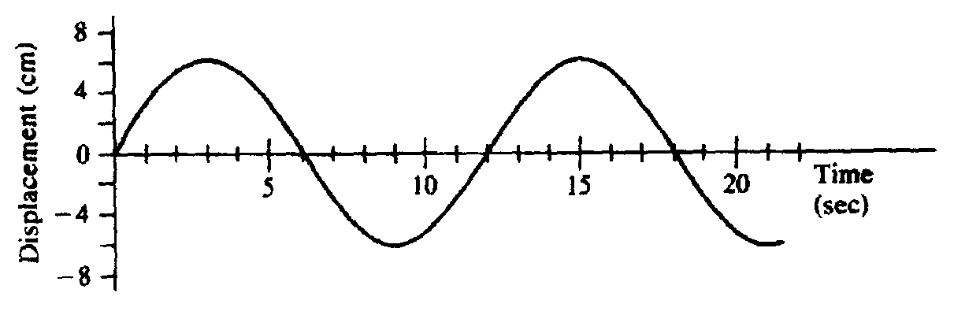
  - What is the period of motion?
  - What is the frequency?
  - What is the angular frequency?
  - What is the amplitude?
  - Write a displacement equation for the motion above.
  - What is the object’s displacement at 10 s?

- The graph below shows an object’s displacement as a function of time.
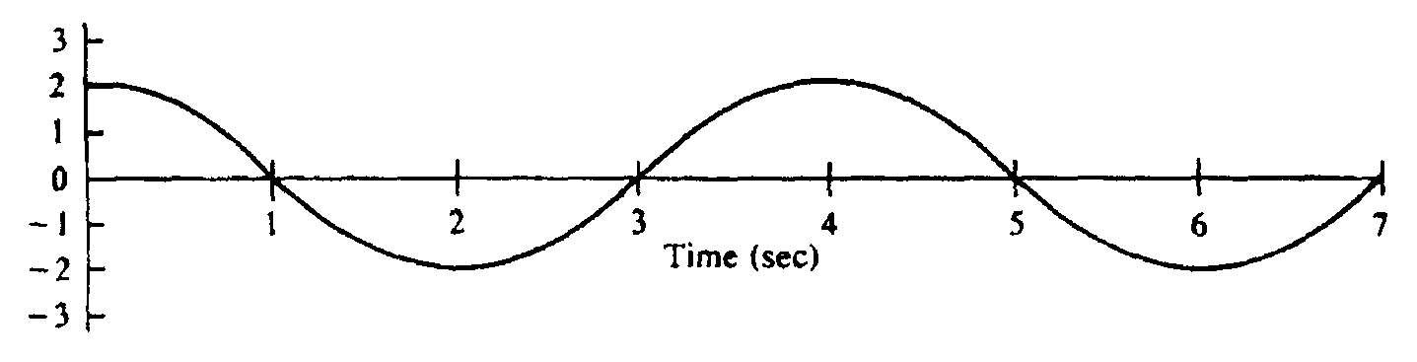
  - What is the angular frequency?
  - Write a displacement equation for the motion above.
  - What is the object’s displacement at 5 s?
  - How far does the object travel in the first 5 s?

- The period of an oscillator is 6 s and the distance between its minimum and maximum displacement is 10 cm. At t = 0 s, it is in the positive amplitude position.
  - Write a displacement equation for the motion described.
  - What is the object’s position at t = 15 s?

- What is the period of a pendulum that is 0.50 m long?

- A pendulum completes 12 cycles in 40 s.
  - What is the pendulum’s frequency?
  - What is the period’s period?
  - What is the length of the pendulum if it is on Earth?

- After landing on Planet X, you carefully measure the period of a 2.0-m long pendulum to be 2.8 seconds. What is the acceleration due to gravity on planet X?

