- A spring stretches 12 cm when a 500 gram mass is attached to the end of it. What is the spring constant of the spring?

- A spring with a spring constant of 5.2 N/m has a relaxed length of 2.45 m. When the spring is stretched to a length of 3.57 m, calculate the elastic potential energy stored in the spring.

- The staples inside a stapler are kept in place by a spring with a relaxed length of 0.150 m. If the spring constant is 51.0 N/m, how much elastic potential energy is stored in the spring when the spring is compressed so that its length is 0.115 m?

- An archer pulls the bowstring back a distance of 0.470 m before releasing the arrow. The bow and string act like a spring whose spring constant is 425 N/m.
  - What is the elastic potential energy of the drawn bow?
  - The arrow has a mass of 0.0300 kg. How fast is it traveling when it leaves the bow?

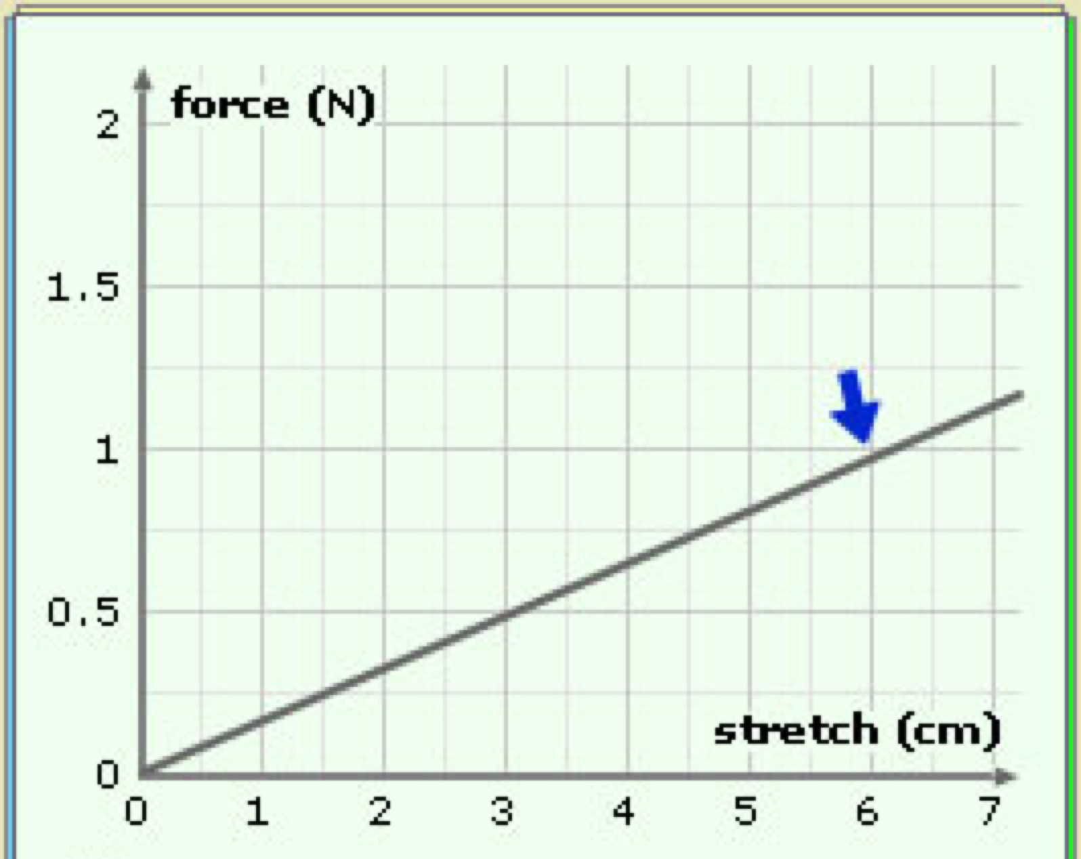
- Using the graph, answer the following questions:
  - What is the spring constant?
  - If the spring is stretched to 5 cm, how much energy is stored in it?
  - If the spring is released after being stretched 5 cm, what velocity will a 0.3 kg mass attached to the spring have when it passes through the equilibrium position?

- A 300-g mass is attached to the end of a spring of spring constant 40 N/m. The spring is stretched 5 cm from the equilibrium position and is released from rest.
  - What is the period of the simple harmonic motion that results?
  - What is the frequency of the motion?
  - Would either answer change if the spring were stretched 10 cm from equilibrium instead of 5 cm when it was released?

