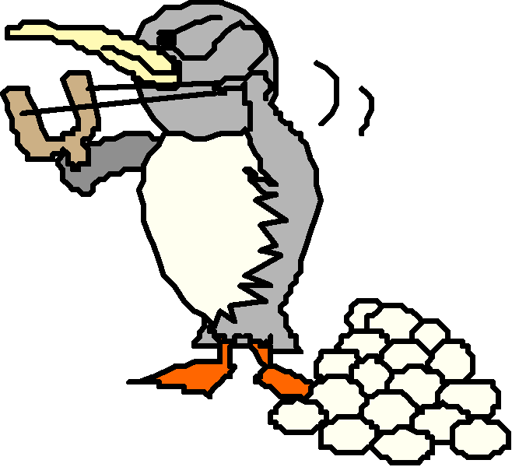

Physics Unit 3: 2D Motion

10-Oct | 11-Oct | 12-Oct | 13-Oct | 14-Oct
Due: --- | Due: Soak Lab |  | Due: --- | Due: GW Type 1
 | WU: Piggy Problem |  | Lect #1 continued: | Lect #2: Trig Review
Lab: Soak! | Return Test | NO SCHOOL | Type I Examples | Vector Practice
 | Lect #1: Intro Proj Mot. |  | Group Work: Type I
HW: Finish Lab | HW: ----- |  | HW: GW Type 1 | HW: PS1
17-Oct | 18-Oct | 19-Oct | 20-Oct | 21-Oct
Due: Vector Pract, PS1 | Due: Bull’s Eye Lab | Due: --- | Due: Range Lab | Due: Poster Idea
WU: Type 1 | Discuss Lab | [PSAT] | Lect #3: Range Equation | Return Quiz
Bull’s Eye Lab | 10 pt Quiz | Lab: Range | & Type II Examples | Discuss Posters
 | Start Lab: Range |  |  | Work on Poster
HW: Quiz Tomorrow | HW: --- | HW: Finish Range Lab | HW: Poster Idea | HW: Poster
24-Oct | 25-Oct | 26-Oct | 27-Oct | 28-Oct
Due: --- | Due: PS2, Poster | Due: GW Type I & II | Due: --- | Due: ---
PS2 | Discuss PS2 | 15 pt Quiz | WU: Monkey Problem | Return Quiz
Work on Poster | GW: Type I & II | Lect #4: Type III Ex. | Lect #4 continued: | PS3
 |  |  | More Type III Ex, PS3 | Conceptual Q’s
HW: Poster & PS2 | HW: Finish GW | HW: Start PS3 | HW: --- | HW: PS3 & Conc Qs
31-Oct | 1-Nov | 2-Nov | 3-Nov | 4-Nov
Due: PS3 & Conc Qs
Practice Test | Unit 3 Test
HW: Test Tomorrow

PS1
1. 321 m/s 2. 38.4 m 3. 7.82 m/s 4. 0.25 m 5. 55.4 m

Group Work: Type I
1. Sketch 2. 7.02 m 3. 4.8 m 4. 14.1 m/s 5. 447 m 6. 1.56 m/s

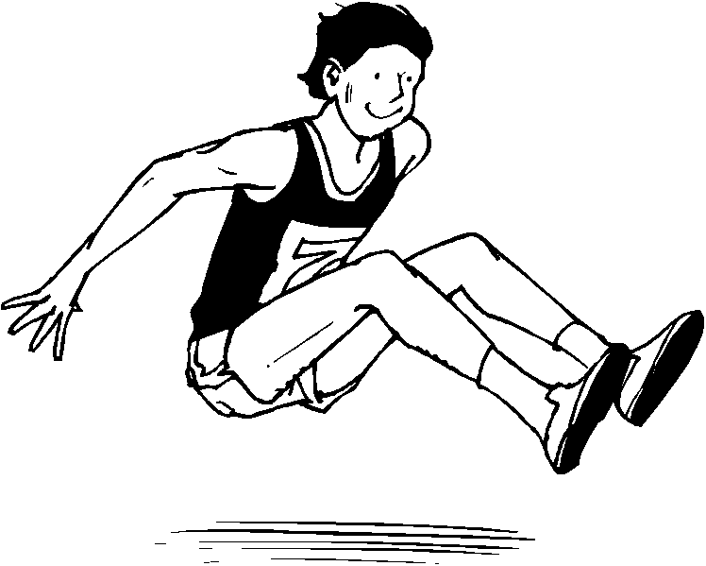
Vector Practice
130 m/s, 75 m/s 16 m/s, 60 m/s
45 m/s, -78 m/s 0 m/s, 12 m/s
14 m/s, 14 m/s 30 m/s, -11 m/s
250 m/s, 0 m/s 17 m/s, 10 m/s
13 m/s, 68° 8.25 m/s, 14°
18 m/s 0° 5 m/s, 53° below x-axis
26.4 m/s, 65° 9 m/s, 90°
23.4 m/s, 50° 20 m/s, 20.2°

PS2
1. 88.7 m, 4.9 s 2. 14 m/s, 13.5 m/s 3. 6.24°, 0.78 s 4. 10.2°, 79.8°, complementary angles lead to the same range 5. 9.4 m/s, 0.96 s, 0.48 s, 1.1 m 6. 92.6 m, 8.7 s, 539 m
Group Work: Type I & II
1. 17.5 m, 1.29 s, 0.65 s, 2.05 m 2. 2.9 m/s, 2.26 s, -22.15 m/s 3. 8.64 m/s, 1.35 s, 2.24 m, 40° 4. 3.43 m

PS3
1. –77.9 m/s, 14.1 s, 1126 m 2. 200 m, 825 m, it’s at that height twice, 93.2 m 3. 93.3 m, 72.5 m/s, 7.8s 4. 241 m, 305.3 m 5. 14.2 m, 91.8 m

