Unit 7: Momentum

MONDAY | TUESDAY | WEDNESDAY | THURSDAY | FRIDAY
30-Jan | 31-Jan | 1-Feb | 2-Feb | 3-Feb
 |  | Due: --- | Due: Balloon Lab | Due: Egg Drop
 |  | Lect: Impulse |  | Return Energy Test
 |  | Lab: Balloon Toss | Lab: Egg Drop | PS1
 |  | HW: Lab Qs | HW: Egg Drop Lab | HW: PS1
6-Feb | 7-Feb | 8-Feb | 9-Feb | 10-Feb
Due: PS1 | Due: Bungee Lab | Due: Mom. WS, PS2 | Due: Conc. Q., PS3 | Due: ---
Lab: Bungee Jump | Discuss Lab | Conceptual Qs | 15 pt Quiz | Lect: 2D Collisions
Analysis Questions | Lecture: Cons. of Mom. | PS3 |  | Example Problems
 | Momentum WS
HW: Finish Lab | HW: PS2 | HW: Conc. Q, PS3 | HW: --- | HW: PS4
13-Feb | 14-Feb | 15-Feb | 16-Feb | 17-Feb
Due: PS4
Return Quiz
Unit Review | Unit 7 Exam
HW: Test Tomorrow

PS 1
- 8.57 x 10³ m/s
- -7.5 kg m/s, 375 N
- 364 kg m/s, 438 N
- 13.5 kg m/s, 6.75 x 10³ N
- 4.5 Ns, 26 m/s, 6.5 kg m/s

Momentum WS
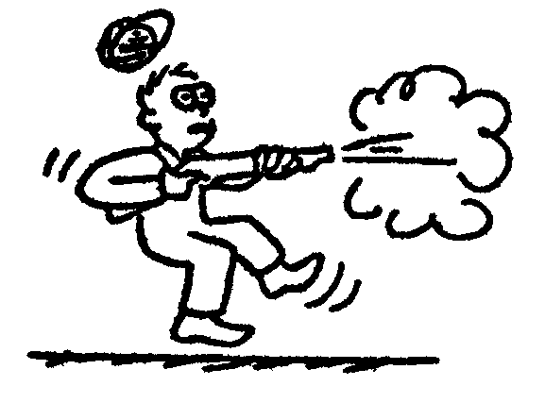
- 3 m/s →
- 2 m/s →
- 6 m/s ←
- 2 m/s →
- 6 m/s →
- 9 m/s →
- 6.67 m/s →
- 4 m/s ←

PS 2
- 0.030 s
- 2.25 kg m/s, 450 N
- 3.75 m/s south
- 4.25 m/s north
- 3 kg
- 0.675 m/s backwards
- 4.8 m/s left
- 2 m/s right

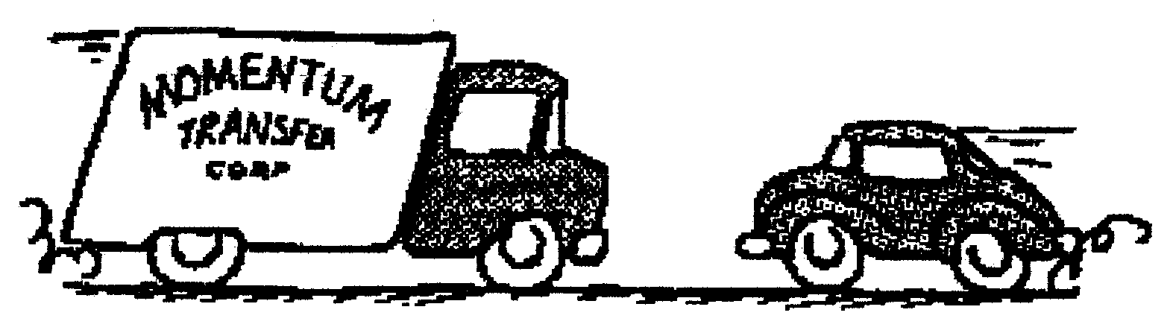
PS3
- 24.5 kgm/s, 0.31 s
- 12 m/s, 9.6 m/s, the first
- 1.7 m/s west
- 1.9 m/s
- 1.1 m/s
- 3.0 m/s
- 5.2 kgm/s west, 0.3 N east
- Yes, no, no, no, yes

PS 4
- 9.3 m/s
- 12.8 m/s
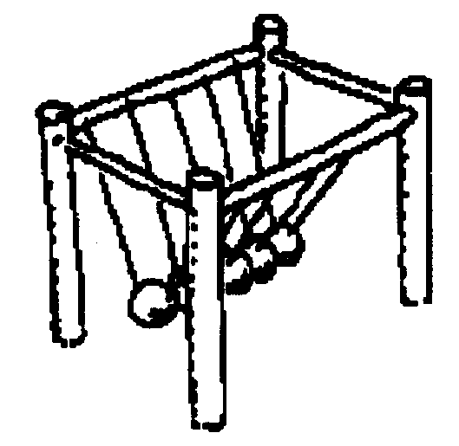
- 0.89 kg in a SW direction
- 15 m/s
- 3.6 m/s
- 1.03 m/s

Review
- 1600 N
- 0.0013 s
- 6685 N
- 0.05 m/s backwards
- 8.8 m/s west
- 0.81 m/s backwards
- 0.06 m/s
- 5.65 m/s
- 19 m/s
- 10 kg m/s, 2.5 kg

