AP Physics C Unit 8: Gravitation

Friday, Feb 10: Unit 7 Challenge, Lect: Law of Gravity HW: PS1
13-Feb | 14-Feb | 15-Feb | 16-Feb | 17-Feb
Due: PS1 | Due: PS2 | Due: PS3 | Due: --- | Due: Conc Qs I
Grade Challenge | Return Exam | Lect: Inside Sphere | Create flip book | Discuss Conc Qs
Lect: Satellite Motion | Lect: Kepler's Laws | Solve AP #1 | Start AP #2 & #3 | 15 pt Quiz
Binary Star Ex #2
HW: PS2 | HW: PS3 | HW: Conc Qs I | HW: Quiz tomorrow | HW: AP #2, #3
20-Feb | 21-Feb | 22-Feb | 23-Feb | 24-Feb
 | Due: ----- | Due: AP Probs 1-3 | Due: Planet Z | Due: AP4, PS4, H&S
No School | Lect: Grav PE, | Return Quiz | Discuss PS4, H&S | Challenge Problem
Presidents Day | Orbital Energy | Planet H & S WS | AP#4, Discuss #1-3 | In-Class: Review
 | HW: Planet Z | HW: PS4 | HW: Conc Qs II | HW: ---
27-Feb | 28-Feb | 1-Mar | 2-Mar | 3-Mar
Due: Conc Qs II
Discuss HW | Unit 8 Exam
Grade Challenge
HW: Study

PS1
- 9.11 x 10⁻³¹ kg
- 0.19 m/s², 15.9 N
- 0.37 kg, 0.75 kg
- 0.61 m/s²
- 6.0 m
- 106 N
PS2
- 1023 m/s, 2.7 x 10⁻³ m/s²
- 5.6 x 10²⁶ kg
- 1.27 x 10³² kg
- 1440 m/s, 9.7 days

PS3
- 7770 m/s
- 119 min, 1630 m/s
- 4.22 x 10⁷ m, 0.285 s
- 2.64 x 10⁶ m
- 22.6 years

AP Problems
1c. CR²/2, 1d. (CR^{2/}M)^{1/2}
2c. T² and r³, 2f. 5.64 x 10²⁶ kg
3a. 4π²r_{a}/T², 3b. 4π²r_{a}(r_{a} + r_{b})²/GT²,
3c. 4π²r_{b}(r_{a} + r_{b})²/GT²
4a. (GM_{e}/2R_{e})^{1/2}, 4b. v₀/2,
4c. -7GmM_{e}/4R_{e}

Planet Z
1. 67 N 2. 1220 m/s 3. 1.7 x 10⁵ s
4. 1.1 x 10⁹ J 5. -2.2 x 10⁹ J 6. -1.1 x 10⁹ J

Planet H & S
- 130 N, 0 N
- 3.41 x 10⁷ m, 2180 m/s
- -2.85 x 10⁹ J, 2.40 x 10¹⁰ J, -2.68 x 10¹⁰ J; -2.85 x 10⁹ J, 2.85 x 10⁹ J,
-5.7 x 10⁹ J
- 3.85 x 10²⁰ m (40,700 light-years)
- 4.57 s
- 2.56 m/s²

PS4
- -4.76 x 10⁹ J, 568 N, 568 N
- 1.84 x 10⁹ kg/m³, 3.27 x 10⁶ m/s², -1.04 x 10¹⁴ J
- 2.55 x 10⁷ m
- -1.45 x 10¹⁰ J, 1.0 x 10⁹ J, -3.13 x 10¹⁰ J, 1.58 x 10¹⁰ J
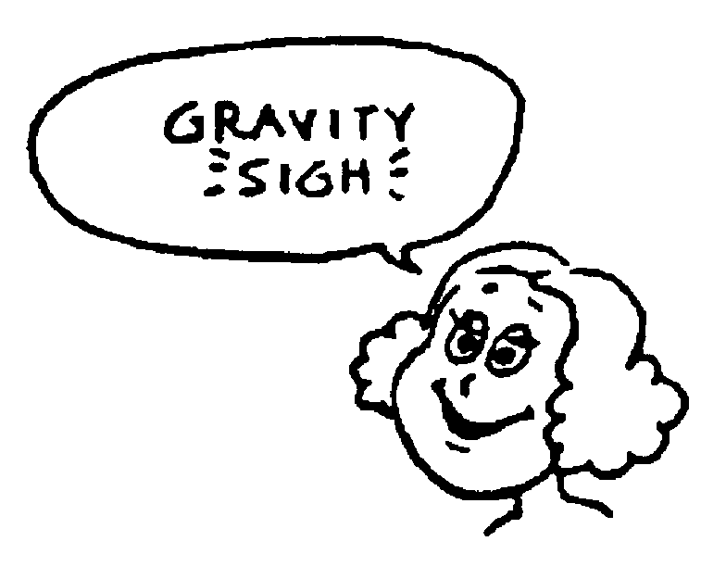
- 1.66 x 10⁴ m/s

Solar System Data
G: 6.67 x 10⁻¹¹ Nm²/kg²
Earth mass: 5.97 x 10²⁴ kg
Earth radius: 6.37 x 10⁶ m
Earth-Sun distance: 1.47 x 10¹¹ m
Earth-Moon distance: 3.84 x 10⁸ m
Moon mass: 7.36 x 10²² kg
Moon radius: 1.74 x 10⁶ m
Jupiter mass: 1.90 x 10²⁷ kg
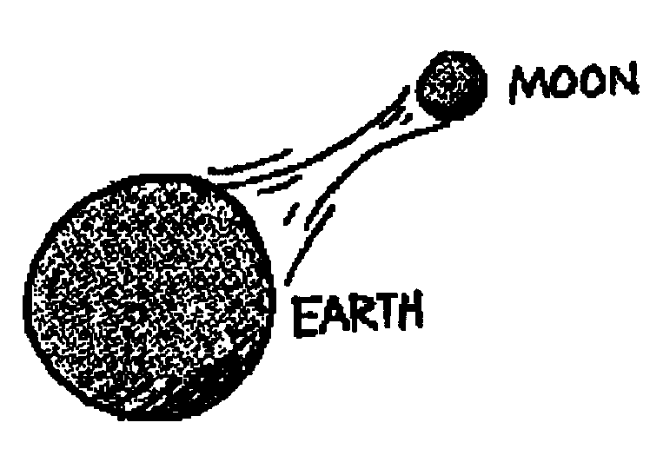
Jupiter radius: 6.99 x 10⁷ m
Sun mass: 1.99 x 10³⁰ kg
7. -8.9 x 10⁹ J 8. 7.8 x 10⁹ J 9.3450 m/s
10. 9.2 x 10⁶ m

