Crossing the River
Questions 1 - 5
The diagram below represents the north and south banks of stream that flows from west to east. The water flows at 3 m/s. The river is 28 meters wide. A boat leaves from dock A on the south bank. The speed of the boat is 4 m/s.
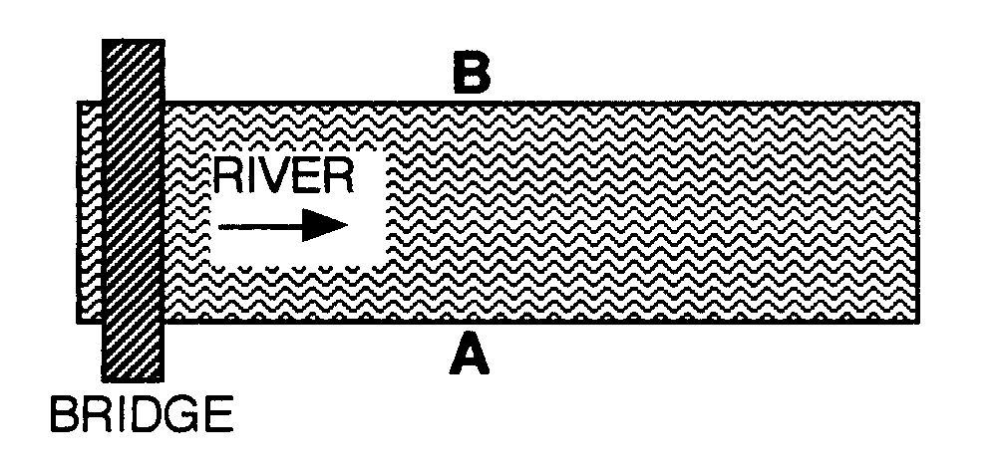
- The boat is kept headed at the opposite shore while crossing the stream. Place an ‘X’ along the opposite shoreline at the place where the boat lands.

- What is the speed of the boat as seen from a bridge overlooking the stream?

- How long does it take the boat to cross the stream?

- How far away from point ‘B’ does the boat land?

- Use an arrow to show the direction the boat should be headed in order to land at dock ‘B’ directly across the stream from the starting location ‘A’.

Questions 6 - 11
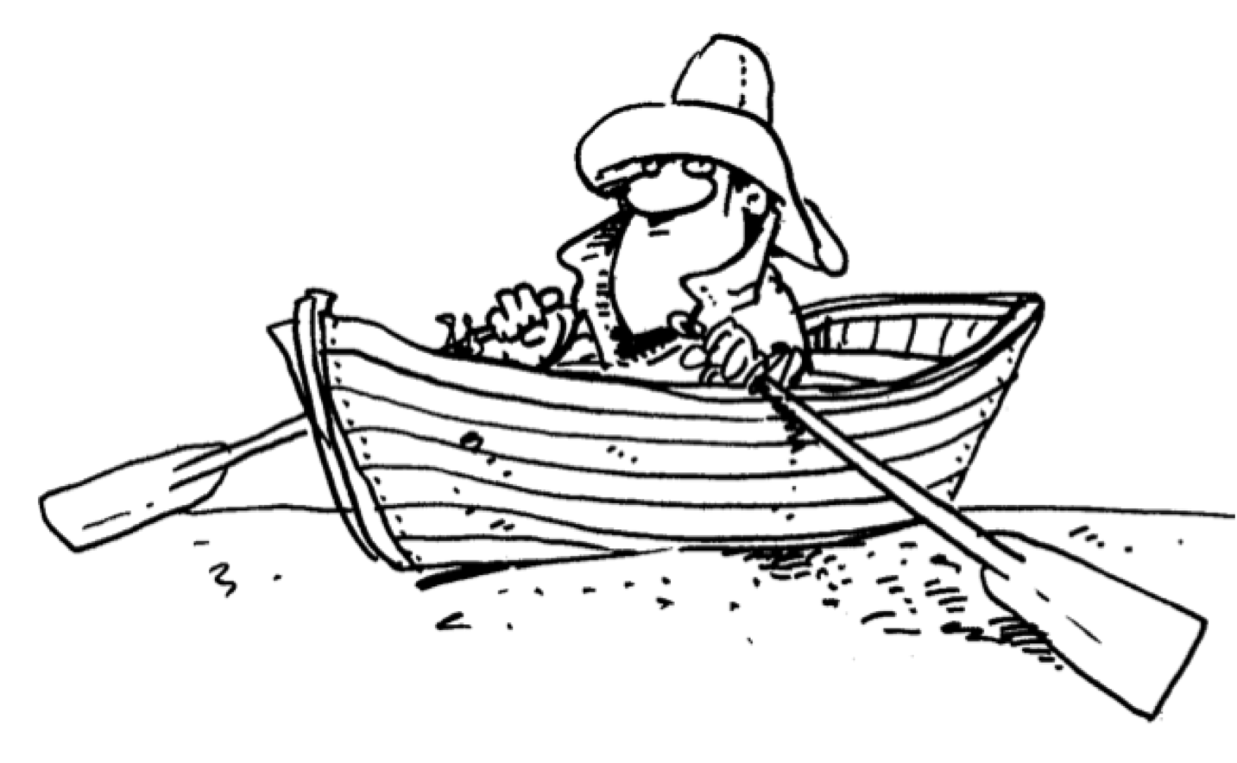
A boat is rowed at 16 km/h directly across a river that is flowing downstream at 12 km/h East. The river is 48 km wide.
- What is the speed of the boat as seen from the bank of the river?

- How long will it take the boat to get across the river?

- How far downstream will the boat land?

- At what angle should the boat head if it wants to end up directly across the river?

- Will it take longer or less time to cross the river in the previous example?

- Determine the time it takes the boat to cross when it ends up directly across.

