SLINKY LAB

PURPOSE: To observe some basic wave characteristics.

MATERIALS: Slinky, meter stick, and stopwatch.

CAUTION: Do not let your extended slinky spring go. It will very likely get tangled and you will be responsible for untangling it or replacing it.
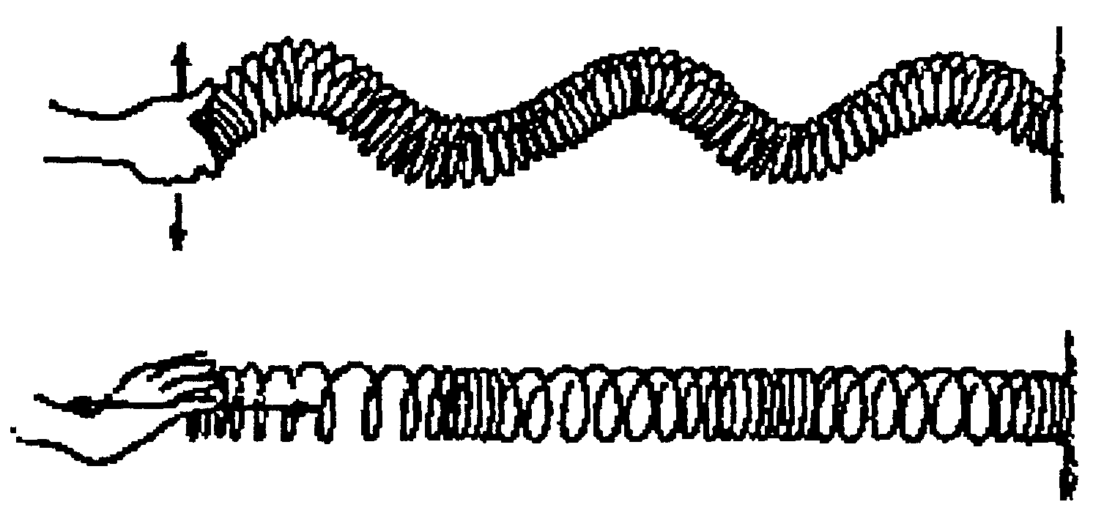

TRANSVERSE

LONGITUDINAL

PROCEDURE:
PART I - You will observe the difference between transverse and longitudinal waves.
Have your partner hold one end of the slinky and stretch it along a smooth floor until it is about 3 m long. Shake your end of the slinky back-and-forth with one quick motion. This should produce a pulse that will travel down the slinky. If you shake your hand back-and-forth in a regular pattern, you will produce a wave train. You are now making a transverse wave.

- As the energy travels down the slinky to your partner, which way does the slinky vibrate? Is this parallel to the direction the wave is traveling or perpendicular?

- Now create a longitudinal wave. Describe what you did with your hand to accomplish this.

- How is a longitudinal wave different from a transverse wave?

PART II - You will observe how the amplitude and density affect the speed of a wave in a given medium.
In this part of the activity you will again keep the length of the stretched spring constant. This will represent a given medium. Generate a transverse pulse in the coil. Measure the amount of time for the pulse to travel down and back. Now repeat the above motion but make it of larger or smaller amplitude.

4. What do you observe regarding the amplitude of a pulse and its speed in a given medium?

Without changing the distance between the people holding the spring, ‘bunch-up’ part of the spring in each person’s hand, so that the spring is stretched more. Send a transverse pulse down this stretched spring and time it.

5. What do you observe about changing the ‘density’ of the spring and the speed of waves that travel down the spring?

PART III - You will investigate the relationships between frequency, wavelength, wave speed, and period.
You are now going to create a standing wave. A standing wave is one that appears to remain in a stationary position (for reasons we’ll discuss later). While you and your partner are still 3 m apart, shake your arm back and forth until you create a standing wave that consists of one loop. Have another partner record how long many times you move your arm back and forth in 10 seconds to achieve this loop. Divide this number by 10 to get the cycles per second - this is the frequency of the wave. Record this value in the chart below.

# of Loops | Frequency (f) | Wavelength | Speed | Period (T)
1
2
3

The wavelength of the wave is the length of two loops. Since your loop is 3 meters long, the wavelength of the wave you created is 6 m. Enter this value in the chart above.

6. Complete the rest of the first row by using the formulas: speed = (wavelength)*(frequency); f = 1/T
Show your work below:

Now generate a standing wave that consists of two loops. Once again, measure the frequency, determine the new wavelength, and use these values to calculate the speed and period. Repeat for a standing wave with three loops.

- Fill in the following with increased, decreased, or remained the same:

  - As the number of loops increased, the frequency _______________________.

  - As the frequency increased, the wavelength _______________________.

  - As the frequency increased, the speed _________________________.

  - As the frequency increased, the period ________________________.

Interpretations

- Do you think the waves you created in this lab were mechanical or electromagnetic? What do you think is the difference between these two types of waves?

- Do you think loud sound waves travel at the same speed as soft sound waves through a given material? Why?

- Do you think sound waves travel at the same speed through air and liquid? Why?

