Santa Monica High School

PHYSICS

COURSE SYLLABUS 2019 - 2020

Ms. Yaghoubian Location: I - 115
ryaghoubian@smmusd.org Phone: (310) 395 - 3204 ext. 71115
website: www.samohiphysics.weebly.com Office Hours: M-Th @ lunch

Welcome to Physics! I am thrilled to have you in class this year. You are about to begin one of the most challenging, exciting, and rewarding science courses offered at the high school level, and I am confident you will be successful. Everything around you can be described using the tools of physics, and the goal of this course is to use basic concepts, equations, and assumptions to describe and explain our physical world. This course will be extremely valuable to you in any science, math, or engineering course you choose to take in the future. My advice to you: Work hard, put forth your best effort, ask for help when you need it, and get ready to use your brain!

Course Topics
Graphical Analysis, 1D Motion Circular Motion
Vectors, 2D Motion Electricity
(Forces and Newton’s Laws – Review) Magnetism
Work and Energy Optics
Momentum

Class Rules

- Do not cheat. Cheating of any kind is NOT tolerated. Students should show work/calculations on all assignments, quizzes, and exams to receive credit. A first cheating offense will result in a ZER0 grade for that assignment, a parent meeting, and a referral to administration for further consequences. A secondary offense will result in a FAIL grade in the course.
- Arrive to class on time and prepared.

Late Work Policy
A calendar and all relevant assignments will be posted on the class website (www.samohiphysics.weebly.com), so students are responsible for being aware of assignment due dates. Assignments turned in one day late will receive a maximum score of 1/3. No assignments will be accepted after one day.

Grading System
Grades will be calculated using total points. Every unit is worth 100 points, and the semester exam is worth 100 points. Projects will be worth additional points depending on the length and complexity of the project. Each unit grade will have the following scoring breakdown:
10 pts – Quiz #1
15 pts – Quiz #2
35 pts – HW and Labs
40 pts – Unit Test

HW and Labs
Doing all of your assignments is the key to success in this course. I cannot stress this enough! At the start of each unit you begin with a 100% in this category – 35 points. This is your grade to keep or lose. Throughout the unit I will check assignments for completion and effort. You will receive a deduction of -2 or -3 in my grade book for any assignment that is not completely done up to standards. This can turn into a -1 if the assignment is fixed by the next class period. At the end of the unit I will add up all the deducted points and reduce your grade of 35 by that amount. If you are absent from class, it is your responsibility to show me any assignments I checked while you were gone on the first day you return to class.

Quizzes and Tests
Quizzes are very straightforward assessments that are timed, but do not take the whole class period. The questions asked will be very similar to ones that you have seen in warm ups, labs, and HW problems. Sometimes they will even be identical. They will help make sure that you are up to speed on your assignments, and they will help me to determine which students need additional help on certain topics.

Tests are given at the end of each unit and are more challenging than quizzes. Tests must be completed within the class period unless a student is legally entitled to extended time. Equation sheets are allowed on quizzes tests.

I expect all students to take the quizzes and tests on the assigned day. To encourage your presence on exam days, you will receive 1 extra credit point on your quiz or test if you take it with your class period on the assigned day. If you are absent the day of a quiz or test, you must make up the quiz on the day you return unless you have made other arrangements ahead of time. The make-up quizzes and exams are different than the regular class quizzes and exams. If you miss more than TWO quiz or test days per semester, you will be ineligible for all extra credit (even extra credit you may have already earned) during that semester. A cumulative semester exam will conclude each semester.

Grading Scale

A+ 97
A 93
A- 90
B+ 87
B 83
B- 80
C+ 77
C 73
C- 70
D+ 67
D 63
D-

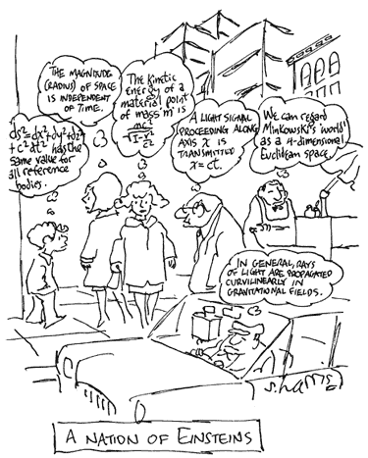
Class policies may be modified during the school year as needed. I will inform the class if and when that becomes necessary.

*Please keep the syllabus for your records and return THIS PAGE ONLY to Ms. Yaghoubian

Santa Monica High School

PHYSICS

COURSE SYLLABUS 2019 - 2020

Student Name: ____________________________________________ ______________________________________________
Last First

Class Period: _____________________

I have read and understood the 2019-2020 Physics Syllabus. __________________ (Initial)

I agree to abide by the SAMOHI Academic Honor Policy. __________________ (Initial)

I understand it is my responsibility to find out the work I’ve missed and
turn it in the day I return from an absence. __________________ (Initial)
I understand quizzes and tests should be taken on time and that I will
forfeit my opportunity for extra credit if I miss more than 2 quizzes
and/or tests per semester. __________________ (Initial)

I agree to participate safely in all lab activities. __________________ (Initial)

Student Signature Date

________________________________________________________________ ________________________________________________________ Parent Name Parent Signature

