PS1: Inclined Planes
*Answers use g = 10 m/s²
- Lab partners Anna Litical and Noah Formula placed a 0.500-kg glider on their air track and inclined the track at 15.0° above the horizontal. Determine the acceleration of the glider along the frictionless track.

- A 5.00 kg mass is released from rest at the top of a frictionless inclined plane as shown. Find:
  - θ
  - acceleration of the mass
  - velocity at the bottom of the plane

- A 6.00 kg mass is released from rest at the top of a 2.00 m long inclined plane as shown. Find:
  - acceleration
  - time to go down plane
  - velocity at bottom

- A 4 kg block is pushed up an incline with a force of 60 N parallel to the plane. The force of friction acting on the block is equal to 5 N.
  - What is the acceleration of the block if the plane is inclined at 20 degrees?
  - The block is now released from rest at the top of the inclined plane. What is its acceleration down the incline? (Hint: The frictional force stays the same.)

- A block starts from rest at the top of a frictionless 30⁰ incline. What is the acceleration of the block?

PS2: Inclined Planes with Friction

- A 5 kg crate slides down an incline of 25⁰. The coefficient of friction between the crate and the incline is 0.25. What is the acceleration of the crate?

- A 3 kg block starts from rest at the top of a 30⁰ incline and slides a distance of 2 m down the incline in 1.50 s. Find:
  - The magnitude of the acceleration of the block down the incline
  - The coefficient of kinetic friction between the block and the plane
  - The frictional force acting on the block
  - The speed of the block after it slides 2 m

- A box of mass M = 10 kg rests on a 35° inclined plane with the horizontal. A string is used to keep the box in equilibrium. The coefficient of friction between the box and the inclined plane is 0.3.
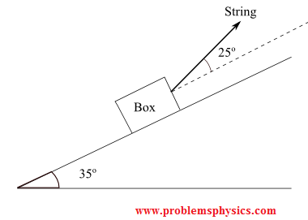
  - Draw a Free Body Diagram including all forces acting on the particle with their labels.
  - Find the magnitude of the tension in the string.
  - Find the magnitude of the force of friction acting on the particle.

