PS 4

- A large icicle of mass 9 kg hangs from a roof 11 m above the ground.
  - How much potential energy does it have?
  - If it breaks off, how much kinetic energy will it have as it strikes the ground?
  - What will be its final speed as it lands?

- A golfer misses a putt and throws his golf club straight up into the air in frustration. His putter has a mass of 7 kg and it leaves his hands at 10 m/s.
  - What is the kinetic energy of the putter as it leaves his hands?
  - What is the maximum height the putter reaches?
  - What is the speed of the putter when it is halfway to its maximum height?

- A girl sets a volley ball straight up in the air with an initial speed of 5 m/s.
  - How high above her hands does it go?
  - How fast is the ball moving when it is 0.4 m above her hands?

- A roller coaster starts from rest at the top of a frictionless track of height 18 m. The car travels to the bottom of the hill and continues up the next hill that is 10 m high.
  - How fast is the roller coaster traveling at the bottom of the first hill?
  - How fast is the roller coaster traveling at the top of the 10-m hill?

- A 60-kg skier leaves the end of a ski jump with a velocity of 25 m/s at an angle of 30° from the horizontal. The ski jump is 80 m above the ground.
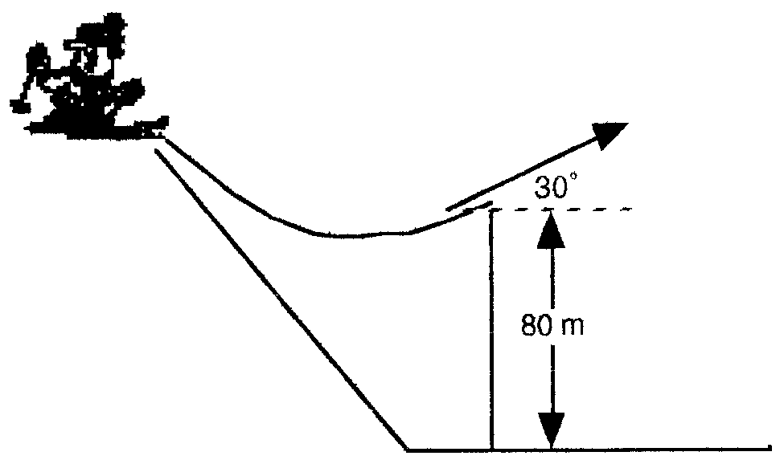
  - What is the skier’s total energy when he leaves the jump?
  - What is the kinetic energy of the skier when the skier reaches his highest point? (Be careful, it’s not zero!)
  - What is the maximum height reached by the skier?
  - What is the skier’s speed just as he lands on the ground below?

