Physics Mini Unit 4: Vectors (50 pts)

13 - Nov | 14 - Nov | 15 – Nov | 16 - Nov | 17 - Nov
Due: --- | Due: --- | Due: Lab: Treasure | Due: Take a Hike | Due: Crossing the River
Lect #1: Vector Addition | WU: Vector Addition | Take a Hike | Lect #2: Relative Vel. | Conceptual Questions
Treasure Hunt Part I | Lab: Treasure Hunt |  | Crossing the River | Review Problems
HW: --- | HW: Lab: Treasure | HW: Take a Hike | HW: Crossing the River | HW: Review Problems
20 - Nov | 21 - Nov | 22 - Nov | 23 - Nov | 24 - Nov
Unit 4 Test |  |  | THANKSGIVING

- Assignments (20 pts)
- Test (30 pts)

Take a Hike
On a hike you undergo the following displacements:
1.5 miles at 30° North of West
2 miles due East
2.5 miles at 75° West of South
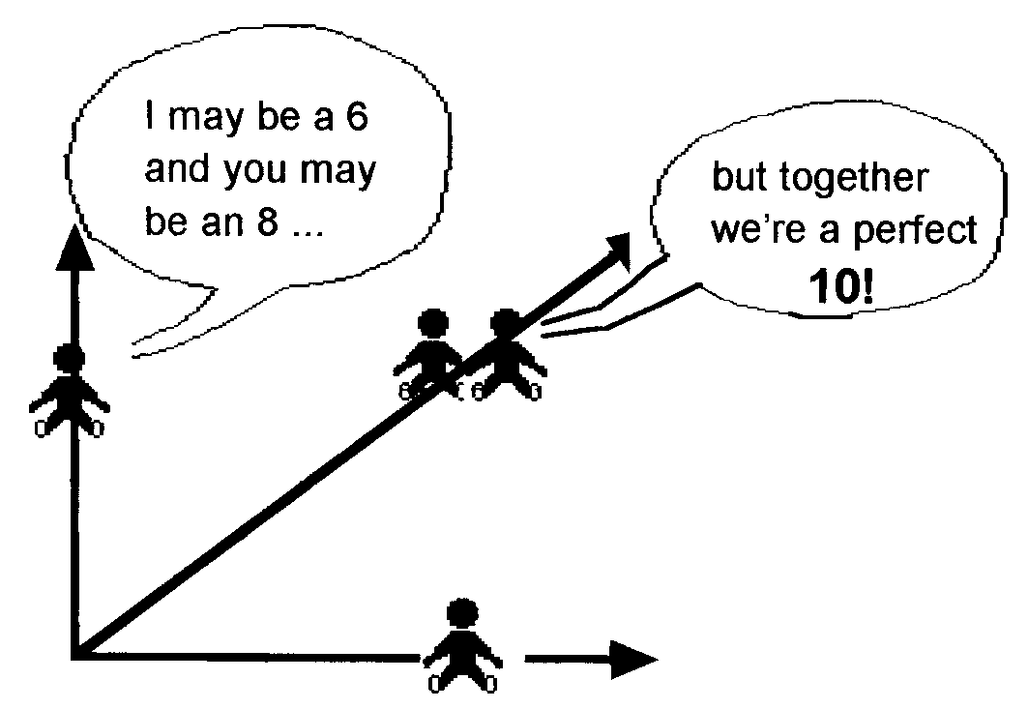
0.5 miles South°
1 mile Northeast

- How far have you hiked?

- Where are you with respect to where you started?
(Solve graphically and mathematically)

Selected Answers
Hike: 7.5 miles, 1.04 miles 17° North of West
River: 1. To the right of B 2. 5 m/s 3. 7 s 4. 21 m 5. Diagonally to the left 6. 20 km/h
7. 3 hours 8. 36 km 9. 48.6° West of North 10. Longer 11. 4.5 hrs
Review: 1. 140 m, 108 m 2. 11.7 m/s @ 31° S of W, 20 s, 120 m 3. 72.1 Newtons @ 34°
N of W 5. 28.9 N, 34.5 N 6. 4.56 m @ 101° 7. 96.8 m @ 158° 8. 70 m, 10 m, yes

