Unit 9: Simple Harmonic Motion

|  |  |  |  |  |
| --- | --- | --- | --- | --- |
| Monday | Tuesday | Wednesday | Thursday | Friday |
| 27-Feb | 28-Mar | 1-Mar | 2-Mar/3-Mar | |
|  |  | Due: ----- | Due: PS1 | |
|  |  | Lect: Intro to SHM | Return Grav. Test | |
|  |  | Examples | Lab: Springs | |
|  |  |  | Lect: Mass-Springs & SHM Examples | |
|  |  | HW: PS1 | HW: Lab Qs & PS2 | |
| 6-Mar/7-Mar | | 8-Mar | 9-Mar (MIN DAY) | 10-Mar |
| Due: Lab Qs & PS2 | | Due: PS3, APs, SHM | Due: --- | Due: Lab |
| More Examples | | Discuss HW | Lab: Tick Tock | Return Quiz |
| AP #1, #2 & More SHM | | **15 pt Quiz** |  | Lect: Pendulums |
| HW: PS3 & More SHM | | HW: --- | HW: Conceptual Qs | HW: PS4 |
| 13-Mar/14-Mar | | 15-Mar | 16-Mar/17-Mar | |
| Due: Conc Qs | | Due: PS4 & PS5 |  | |
| CHALLENGE PROBLEM | | Review MC | **Unit 9 Exam** | |
| PS4 & PS5 | |  |  | |
| HW: PS4 & PS5 | | HW: Exam Tomorrow |  | |

PS1: pg. 414 (1, 3, 4, 5)

1. 1.50 Hz, 0.667 s, 4.00 m, π rads, 2.83 m

3. 20.0 cm, 94.2 cm/s – equilibrium, 17.8 m/s2 – turning pts

4. 4.33 cm, -5.00 cm/s, -17.3 cm/s2, 3.14 s, 5.00 cm

5. x = (2.00 cm) sin 3.00πt, 6.00π cm/s, 1/3 s, 18.0π2 cm/s2, 0.500 s, 12.0 cm

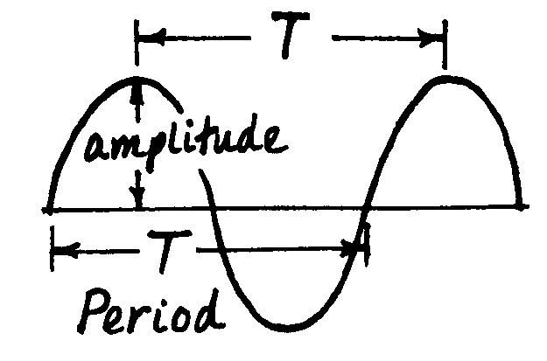

PS2: pg. 415 (7, 8, 9, 11, 15)

7. 0.627 s

8. 2.40 s, 0.417 Hz, 2.62 rad/s

9. 40.0 cm/s, 160 cm/s2, 32.0 cm/s, ±96.0 cm/s2, 0.232 s

11. 40.9 N/m

15. 0.628 m/s

AP #1, #2

1. 200 N/m, 1 J, 2 J, 1.1 m/s, 600 N/m

2. f/m1, (m1 + M2)f/km1, sinusoidal, f/m1, (kA’ – f)/M2

Multiple Choice

1. B 2. D 3. E 4. D 5. D 6. E 7. D

8. C 9. D 10. D 11. D 12. D 13. D 14. C

PS3: pg. 415 (17, 18, 19, 20a-e, 22)

17. 2.23 m/s

18. 0.153 J, 0.784 m/s, 17.5 m/s2

19. 28.0 mJ, 1.02 m/s, 12.2 mJ, 15.8 mJ

20. 100 N/m, 1.13 Hz, 1.41 m/s, 10.0 m/s2, 2.00 J

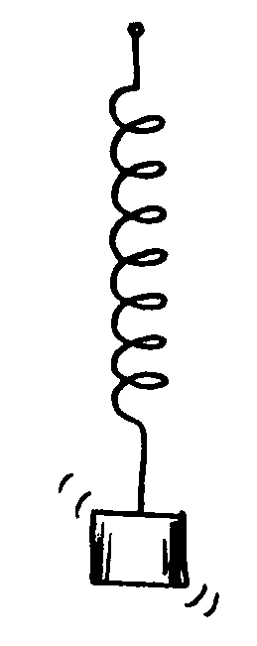22. E quadruples, vmax and amax double, period is unchanged

PS4: pg. 416 (25, 29a+c, 30, 32)

25. 35.7 m, 29.1 s

29. 0.817 m/s, 0.634 N

30. 3.65 s, 6.41 s, 4.24 s

32. calculated g’s (in m/s2): 9.91, 9.87, 9.76, mean = 9.85 m/s2

PS5: pg. 415 (12, 21, 49, 53, 63)

12. 0.542 kg, 1.81 s, 1.20 m/s2

21. 2.61 m/s, 2.38 m/s

49. 6580 N/m

53. 6.62 cm

63. 3.00 s, 14.3 J, 25.5°