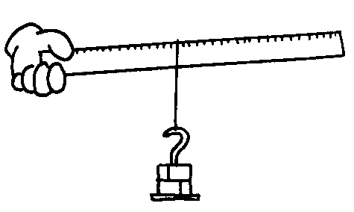
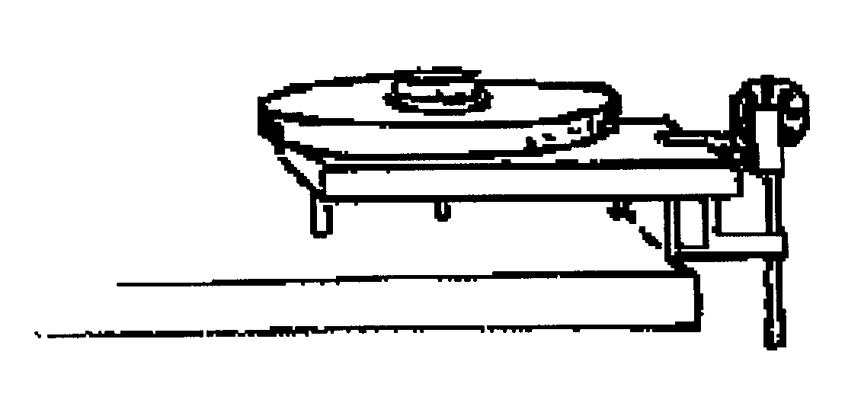
FINAL UNIT OF THE YEAR!
UNIT 10: ROTATIONAL MOTION

Monday | Tuesday | Wednesday | Thursday | Friday
14-Mar | 15-Mar | 16-Mar | 17-Mar | 18-Mar
 |  | Due: ----- | Due: PS1 | Due: -----
 |  | Lect: Intro Rotation | R. Inert, P. Axis Thm | Finish Lecture
 |  |  | Return SHM Test | Start Torque Lab
 |  | HW: PS1 | HW: --- | HW: PS2
Spring Break March 19 – April 3
HW: MC & FR Practice
4-Apr | 5-Apr | 6-Apr | 7-Apr | 8-Apr
Due: PS2 | Due: Lab | Due: PS3 | Due: Rotation Recap | Due: Pulley Ex #2
Torque Lab | Lect: Torque | Static Equilibrium | 10 pt Quiz | Return 10 pt Quiz
Review SB HW |  | Examples | Pulley Example | Cons. of Energy
HW: Lab Qs | HW: PS3 | HW: Rotation Recap | HW: Pulley Ex #2 | HW: PS4
11-Apr | 12-Apr | 13-Apr | 14-Apr | 15-Apr
Due: ----- | Due: PS4, EWP | Due: AP #1&2 | Due: ----- | Due: Conc Qs
Discuss PS4 | Physical Pendulums | 15 pt Quiz | Lect: Cons of Mom. | Return Quiz
Energy, Work, Power |  |  | Examples | AP#3 & #4
HW: AP #1&2 | HW: Quiz Mon | HW: Conc Qs | HW: PS5 | HW: Review
Per. 1/3/5 18-Apr | Periods 2/4/6 19-Apr | 20-Apr | 21-Apr | 22-Apr
Due: PS5, AP#3&4 |  | All Classes | 1/3/5 | 2/4/6
Unit Review
 |  | Unit 10 Exam
HW: Test Wed
PS4: Work and Energy pg. 321 (42, 43, 45, 48) pg. 350* (4)
42. 56.3 J, 8.38 rad/s, 2.35 m/s, very close (2.34 m/s)
43. 2.36 m/s
45. 11.4 N, 7.57 m/s², 9.53 m/s, 9.53 m/s
48. 10.3 min
4. (4gh/3)^.5, (gh)^.5, the disk reaches bottom first

PS1: Kinematics pg. 317 (3, 6, 7, 8, 18, 19)
3. 1200 rad/s, 25.0 s
6. -226 rad/s²
7. 5.00 rad, 10.0 rad/s, 4.00 rad/s², 53.0 rad, 22.0 rad/s, 4.00 rad/s²
8. 50.0 rev
18. 29.4 m/s², -9.8 m/s²
19. 126 rad/s, 3.77 m/s, 1260 m/s², 20.1 m

PS2: Rotational Inertia (Worksheet)
Energy, Work, and Power
1. 7.67 rad/s
2. H = 13.9 m/s, CYL = 16.0 m/s, S = 16.6 m/s, CU = 19.6 m/s
3. 190 rad/s
4. 6.53 m/s², 1.75 s, 11.4 m/s, 32.7 N
5. 91.8 kgm², 0.817 rad/s², 2.45 rad/s, 276 J, 9.00 m/s², 1.22 m/s², 92 W, 184 W

1. 92.0 kg*m², 184 J, 6.00 m/s, 4.00 m/s, 8.00 m/s, 184 J
2. 0.00625
3. 3MR²/2, 7MR²/5
4. 115 J, 13.3 m/s, 253 m/s²
5. 548 kgm², 350 kgm²

PS3: Torque pg. 320 (32, 33, 37, 38, 40)
32. 177 kg
33. 3.55 Nm
37. 24.0 Nm, 0.0356 rad/s², 1.07 m/s²
38. 21.6 kgm², 3.60 Nm, 52.4 rev
PS5: Ang. Momentum pg. 351* (19, 31, 34, 37, 54)
19. 17.5 kg*m²/s
31. 0.433 kg*m²/s, 1.73 kg*m²/s
34. 7.14 rev/min
37. 0.360 rad/s CCW
54. 6mv_{i}/(Md + 3md), M/(M+3m)

40. 0.312

Rotation Recap
1. 99 kgm², 7.6 m, 53.6 Nm CW
2. 5 rad/s², 250 rad, 39.8 rev, 15 m/s, 0.15
3. 1.53 kgm², 7.66 rad/s², 11.7 Nm, -4.59 x 10⁴ J, a & d

